Chapter 10, Solution 72.

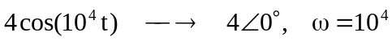
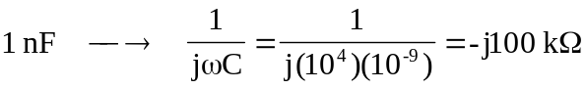

Consider the circuit as shown below.
+
−
+
−
50 k
-j100 k
V_{o}
V_{o}
40 V
I_{o}
100 k

At the noninverting node,
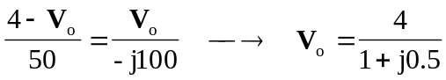

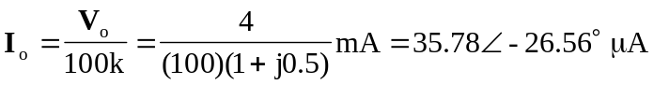

Therefore,
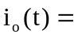 35.78cos(10⁴t–26.56) A

